

UNISA STEM

INFS 1026 – Systems Requirements and User Experience (SRUX) 

Assignment 2: User Experience Design for a Paramedical Emergency   
Response System

Table of Contents

DECLARATION OF CONTRIBUTION 3

Task 1 – Identifying User Experience Stakeholders For Dispatch and Driver 4

Identify Stakeholders in Dispatching and Driving process 4

General information of Stakeholders 5

Task 2 – Interview Plan 6

Interview Outline 1 6

Interview Outline 2 9

Task 3 – Project and System Stakeholder Interview Transcript 11

Interview transcript 1 11

Interview transcript 2 14

Task 4 –User Stories Relevant to the user experience 17

Ambulance Driver/ Paramedic User Stories 17

Dispatcher User Stories 18

Task 5 – Personas 20

Dispatcher 2 21

Paramedic 22

Task 6 – Matrix of User Stories to Persona’s 23

Task 7 – Storyboards 26

RESPONSE SYSTEM 26

DISPATCHING SYSTEM 26

BOTH SYSTEMS (DISPATCH & RESPONSE) 29

Task 8 – Information Architecture/Look and Feel 32

Typography 32

Colour palette 32

Case Category color options: 32

Task 9 – Priority List of User Stories (AKA Backlog) 36

Paramedic/Ambulance Driver User Stories Ordered by Importance. 36

Dispatcher User Stories Ordered by Importance. 37

Task 10 – Prototype 38

Ambulance Driver (Response Process) 38

Dispatcher (Dispatching Process) 43

REFERENCES 50

## DECLARATION OF CONTRIBUTION

**Team No/Name:    24240-06    AJA**

The following is a declaration of your individual contributions towards this group assessment. If any contribution does not meet the assessment requirements, the course coordinator may adjust individual marks up or down, depending on the level of contribution made.

**Team Member 1**

Name:               An Truong

I contributed 3500 words towards this assessment.

I worked on the following sections/questions (select whichever is appropriate).

* Contributed to the User Stories.
* Contributed to both questionnaires.
* Completed interview transcripts.
* Completed the matrix of user story persona
* Contributed to storyboards.
* Contributed to Identify Stakeholders
* Completed the Prototype

**Team Member 2**

Name:               An Dao

I contributed 3500 words towards this assessment.

I worked on the following sections/questions (select whichever is appropriate).

* Contributed to the User Stories.
* Contributed to both questionnaires.
* Completed interview transcripts.
* Completed the matrix of user story persona
* Contributed to storyboards.
* Contributed to Identify Stakeholders
* Completed the Prototype

**Team Member 3**

Name: Jack Haggerty

I contributed 3500 words towards this assessment.

I worked on the following sections/questions (select whichever is appropriate).

* Contributed to the User Stories.
* Contributed to both questionnaires.
* Completed interview transcripts.
* Completed 3 personas.
* Completed User Story prioritisation.
* Contributed to information architecture.
* Contributed to storyboards.

## Task 1 – Identifying User Experience Stakeholders For Dispatch and Driver

### Identify Stakeholders in Dispatching and Driving process

|  |  |  |
| --- | --- | --- |
| **Stakeholder types** | **Stakeholders** | **Role in system \***  **(Participate in process)** |
| **Non-user Stakeholders**  **(Indirectly use the system)** | * Caller * Headquarter Dispatcher * Fleet and Medical Supply Staff * Hospital staff      * Emergency Operation Centre (EOC) * Patients | Dispatching |
| Responding |
| **User Stakeholders**  **(Directly use the system)** | * Call Taker * Dispatcher        * Ambulance Crew (Paramedics) | Dispatching |
| Responding |

*Mainly participate in the process.

### General information of Stakeholders

**Non-user Stakeholders**

**Caller**

Caller can be patient or nearby person that ring Triple Zero (000) calls to ask for help. Caller is the one who indirectly use the system via phone to provide necessary information about the case for Call Taker.

**Headquarter Dispatcher**

Headquarter Dispatcher is the one who takes over and responsible for handling cases central Adelaide, Southern, Northern and Hills regions around SA. Triaged cases will be sent to the nearest Headquarter, which always has 20 Ambulance Crews on average. Adelaide Headquarters are places to SA Ambulance centralizes Dispatchers.

**Fleet and Medical Supply Staff**

Fleet and Medical Supply Staff prepare ambulance service, supply, and stock medical equipment and medicines. These staff are not directly using the system during the dispatch and response process, however, they are the core factor that support and maintain the good flow of the process.

**Emergency Operation Centre (EOC)**

EOC houses around 15 patient service staff including emergency medical dispatch support officers (responsible for answering 000 calls), emergency medical dispatchers (who coordinate the state’s ambulance resources) and the rescue helicopters. EOC is called for exceptional cases that requires the cooperation of more than 2 types of human support services.

**Hospital staffs**

Hospital staffs receive patient/ cases’ information from dispatcher, notify and update hospital status for dispatcher and give treatment to patients. Each hospital has different capabilities of their recent facilities condition as well as specify their own policy and requirements for various cases.

**Patients**

Patients can be the persons who directly call for ambulance services or mostly are the one who use the result of the system process as they just take part in during the response process and so on to apply them with their treatment.

**User Stakeholders**

**Call Taker**

Call Takers at a centralized call center receives and triage 000 emergency calls. They assign the degree of cases’ urgency and give first aid advice at various points if needed. Call Takers participate in the process of Dispatching as they are the ones who use system to inform Dispatchers about new cases.

**Dispatcher**

Dispatchers are centralized to Headquarters spread around the state. After receiving the case that has been categorized by Call Taker, they consider the urgency of the case, then find and assigned it to the suitable Ambulance Crew. Dispatchers are responsible for the process of finding available Paramedics to group up to a group and check the requirements in hospital facilities whether it match with the condition of patients.

**Ambulance Crew (Paramedics)**

Paramedics often work in ambulances. They are dispatched by dispatcher to respond to emergency calls by driving to the scene. Then they assess and treat patients as needed. Ambulance Crew is a group of 2 Paramedics in one Ambulance with one is nominated as Ambulance Driver. Ambulance Crew are responsible finding the best route to reach patient location, access hospital facilities and the policy of that hospital during that time.

## Task 2 – Interview Plan

### Interview Outline 1

|  |  |
| --- | --- |
| Interviewee: Ambulance Driver (Ben Mills) | Interviewer: |
| Location/Medium: in person | Appointment Date:  Start time:  End time: |
| Objectives:  To gather requirements for the response team part of the new system and to further understand the role of a paramedic. | Reminders: |
| Agenda: | Approximate Time: |
| General Observations: | |
| Unresolved Issues, Topics Not Covered: | |
| **Questions** | **Notes** |
| Question 1:  Could you share how you use the current response system to take over a typical case? | Answer:    Observations: |
| Question 2:  On a scale of 1 to 5, how easy is the current system to learn to use? (5 being hardest, 1 being easiest) | Answer:    Observations: |
| Question 3:  Are there times the current systems lack of effective functions makes your job more complicated? | Answer:    Observations: |
| Question 4:  How do you think the current system could be improved? | Answer:    Observations: |
| Question 5:  Do new cases get automatically routed in the GPS system or does the address need to be manually entered? | Answer:    Observations: |
| Question 6:  Are there any processes that could be automated in the new system? | Answer:      Observations: |
| Question 7:  Would you benefit from having each category of severity having different colors? | Answer:      Observations: |
| Question 8:  Would you benefit from audible ques when a new case arrives? | Answer:        Observations: |
| Question 9:  How does the current system display hospital status? For example, weather the hospital is ramping or having other issues? | Answer:    Observations: |
| Question 10:  How does the current system display the latest policies or procedures? For example, what are the policies or procedures for handling COVID-19? | Answer:    Observations: |
| Question 11:   What do you like the most about the current system? | Answer:    Observations: |
| Question 12:  What do you like the least about the current system? | Answer:      Observations: |

### Interview Outline 2

|  |  |
| --- | --- |
| Interviewee: Dispatcher (Sally Smith) | Interviewer: |
| Location/Medium: in person | Appointment Date:  Start time:  End time: |
| Objectives: to gather requirements about the dispatcher end of the new system and to further understand the role of a dispatcher. | Reminders: |
| Agenda: | Approximate Time: |
| General Observations: | |
| Unresolved Issues, Topics Not Covered: | |
| **Questions** | **Notes** |
| Question 1:  Could you share about the process to dispatch a typical case? | Answer:    Observations: |
| Question 2:  How do you notify other dispatchers of an ambulance going the same area and a previous one? | Answer:    Observations: |
| Question 3:  Do you have access to an integrated map? | Answer:      Observations: |
| Question 4:  On a scale of 1 to 5 how easy is the current system to learn to use? (5 being hardest, 1 being easiest). | Answer:      Observations: |
| Question 5:  Do you think ease of use is important for the new system? | Answer:      Observations: |
| Question 6:  Are there any processes in the current system that can be automated? | Answer:    Observations: |
| Question 7:  How do you know which ambulances are available? | Answer:      Observations: |
| Question 8:  Is there any time the information given from the Call Taker is unclear or not detailed enough to dispatch the case? | Answer:        Observations: |
| Question 9:  What do you like the most about the current system? | Answer:    Observations: |
| Question 10:  What do you like the least about the current system? | Answer:    Observations: |

## Task 3 – Project and System Stakeholder Interview Transcript

### Interview transcript 1

*Interviewer: XXXX*

Interviewee: Ben Mills (Ambulance Driver)

Date: 16/06/21

Location: UNISA

*Interviewer: Hey there Ben, very nice to meet you and thanks for sitting down with us!*

Ben: No problems, happy to be here!

*Interviewer: alright so we have a short list of questions here that are going to help us gather requirements for the new ambulance response system we are developing. Please answer however you feel is suitable, some are close ended, and some are open ended. Does that sound okay for you?*

Ben: yes, that sounds great, ask away!

*Interviewer: alright let's get started! Could you share how you use the current response system to take a typical case?*

Ben:  Sure! So, while one of us drives the other is keeping an eye on the terminal for any incoming cases. Once the system receives a case, we acknowledge that we have received the notification and signal that the are on route. Once we get to the patient, we decide whether or not they need to be transported to hospital, if they do, we transport them to the nearest hospital. Sometimes we can just treat them on the site and move on but more often than not with higher category cases we need to take them to hospital.

*Interviewer: Great. Does the current system give you access to hospital status? For example, if the hospital is ramping or having other issues?*

Ben: the current system doesn’t have a feature that gives us feedback on hospital status. Having that in the new system would save lives! We currently don’t have any way of knowing what is happening at the hospital until we get there, we just use our general knowledge to assess which hospital we take the patient too.

*Interviewer: okay so a feature that allows communication or status updates from hospitals in the area would be something response crews would benefit from?*

Ben: yes, that would be extremely beneficial to us.

*Interviewer: all right I will take note of that. Next question! On a scale of 1 to 5, how easy is the current system to learn to use? (5 being hardest, 1 being easiest).*

Ben: Oh, I would say about a 2, there is a small learning curve but overall, it is fairly easy to pick up.

*Interviewer: do you think that is important for the new system?*

Ben: yeah, I think, keeping it simple would be good. Making it needlessly complex wouldn’t be suitable in my opinion.

*Interviewer: okay, are there times the current system complicates your work?*

Ben: I would say no, like I said the current system is extremely basic and simple to use, if anything I would say that it is too simple and lacks luxury features and automated processes.

*Interviewer: okay, in your opinion, how do you think the current system could be improved?*

Ben: well, one of the bigger issues we face with the current system is the GPS does not have access to traffic data, run into traffic jams sometimes and it really slows us down. Our response times need to be as fast as possible and it is frustrating knowing that this is available as a feature, and we do not have it!

*Interviewer: so, the current GPS just finds the route that travels the least number of kilometers, where a longer route might be faster because of the lighter traffic?*

Ben: yes, exactly. Sometimes we know not to take main north road at 5pm because we know that traffic will hold us up. But a system that shows alternate routes would be great.

*Interviewer: okay we will take that into consideration. While we are talking about the GPS, are new cases automatically routed in the GPS system or does the address need to be manually entered?*

Ben: the current system just displays the information and then we need to manually enter the address into the GPS, it would be a nice feature to have the address automatically routed upon us acknowledging the case. This would save us time.

*Interviewer: okay great. Are there any other processes that could be automated in the new system?*

Ben: perhaps automatic estimated time of arrival messages, so patients don’t have to call back for updates on how long we are going to be.

*Interviewer: Great idea, anything else?*

Ben: um, I can't think of anything right now sorry. I am not the most IT literate person.

*Interviewer: That’s all good! Let's move on then, would you benefit from having each category of severity having different colors?*

Ben: well, that would be very helpful. However, I'm actually colorblind so I would need to have different settings to filter out colors I have trouble with. I have trouble with greens and reds, which is common for people that suffer from this issue.

*Interviewer: Oh really, this is unexpected! Does the current model not support colorblind modes?*

Ben: No, it doesn’t. However, there isn't any color coding for case categories. So, I can get by using it. But I think having these color codes would be very helpful for us, but my condition should be taken into account when creating this feature. I think just implementing this for the category colors would be okay, the whole user interface does not need to be filtered.

*Interviewer:  Of course, we will be taking note of this and will be implementing different color modes. More research will need to be done on this topic.*

Ben: That would be muchly appreciated, thank you for being considerate of this issue.

*Interviewer: No problem, this is exactly why we conduct these interviews, you never know what will come up! To continue on the arrival of cases, would you benefit from audible ques when a new case arrives?*

Ben: hmm, that’s actually a good idea, that would be very helpful, yes! The current system doesn’t have anything like that, a case might sit there for a minute sometimes before we notice it there. A minute might not seem like much but for someone having a heart attack or stroke that is the difference between life and death. A loud ring or a tone would definitely get our attention immediately.

*Interviewer: How does the current system display the latest policies or procedures? For example, what are the policies or procedures for handling COVID-19?*

Ben: we are briefed on these procedures. However, the current system doesn’t have these on display.

*Interviewer: do you think you would benefit from having the system display that information?*

Ben: it wouldn’t hurt, it would be a good way to remind us to be cautious and to follow the procedures properly. The COVID-19 period has been stressful on us all.

*Interviewer: Yeah, I can imagine working in health care during a pandemic would be difficult, I have a huge amount of respect for anyone that does so!*

Ben: Yes, trying to treat a patient and limit the spread of the virus just adds another level of difficulty to an already difficult job but we do what we got to do.

*Interviewer: well, what you guys do is appreciated by us all. Okay, nearly done! What do you like the most about the current system?*

Ben: the current system has issues and limitations, but the simple nature of it makes it easy to use and easy to pick up. I think that one of the main strengths of the system is its ease of use.

*Interviewer: okay great, final question; What do you like the least about the current system?*

Ben: that would be the GPS system not having traffic data, this is something that is very frustrating for the response teams. We need the system to show us alternate routes we can take if there is traffic congestion.

*Interviewer: okay so the GPS system is a huge pain point right now, we will be taking this in consideration for the new system. That pretty much all we had for you Ben we appreciate the time you have spent with us; it was extremely helpful!*

Ben: no problems thanks a lot for having me, I am happy to help!

*--end transcript*

### Interview transcript 2

*Interviewer: XXXX*

Interviewee: Sally Smith (Ambulance Dispatcher)

Date: 17/06/21

Location: UNISA

*Interviewer: Hey there Sally very nice to meet you and thank you very much for sitting down with us today!*

Sally: hey! No problems nice to meet you as well.

*Interviewer: as you probably already know we are currently in the process of collecting requirements for the new dispatch system for SA Ambulance. We have interviewed the response teams and now we’re onto the dispatch side of things. So, we have constructed a brief list of questions for you that will invite conversation and hopefully give us an idea of what you guys need to have in the new system, if it is okay with you would you like to get started?*

Sally: sure! I am ready to go, I just wanted to say I appreciate the work you are doing; we are in desperate need of an update for the system!

*Interviewer: Really? well lucky we’re here! Okay Sally can we please start by you talking us through the process of dispatching a typical case?*

Sally: Sure! so after a caller has given all their information to the call taker, the case is forwarded to me. The case is displayed on my screen hopefully with the valid information needed for dispatch. Then I need to look for an available ambulance from the list and send the closest one to the case. Once that is done, I have to let all the other dispatchers in the office know that I have just sent an ambulance to that suburb and that’s pretty much the full process.

*Interviewer: how do you notify the other dispatchers of an ambulance going to the area?*

Sally: we have to call out to everyone.

*Interviewer: verbally? So, there is no map integrated into the system that shows where all the ambulances are?*

Sally: yes, verbally, and no, there is no map showing where all the ambulances are. We need one!

*Interviewer: yes, it sounds like you do! We had similar complaints from the paramedics.*

Sally: Yes, we hear about their frustrations all the time! Another issue with that is if another dispatcher gets a case in the same suburb, they have no way of knowing if it is the same case as the previous one. So, they have to ask the dispatcher that sent the first ambulance to the area if the cases are the same or related. If feel like the system should be able to help us out with this. It sometimes takes a few minutes to figure this out, we have to compare the notes on the case and addresses to ensure that it is a separate case and needs another ambulance.

*Interviewer: I can see how that would be time consuming and inefficient. So, the new system needs to have features that can signal that a case might have already been answered?*

Sally: yes, if we had a map that showed marks where cases are and if they have been addressed, we would be able to tell faster.

*Interviewer: right, that could be implemented, so the map feature needs to show all ambulances in real time and show where acknowledged cases are so dispatchers can see who is nearby and if the case has been answered?*

Sally: yes, that would be a huge upgrade from how we currently do things, so much time and potentially lives will be saved!

*Interviewer: it seems this new system cannot be developed fast enough! An update sounds well overdue. So, on a scale of 1 to 5, how easy is the current system to learn to use? (5 being hardest, 1 being easiest).*

Sally: I would say a 1. I find it basic and easy to learn.

*Interviewer: do you think that is important for the new system?*

Sally: the current system is lacking and has lots of areas that need improvement, the new system can have a higher level of complexity if it means we can have luxuries like access to a map and automated processes.

*Interviewer: okay great, since you mentioned automation, are there any processes in the current system that can be automated?*

Sally: the adding of ambulances back into the available list is currently needed to be done manually, we have to search for the ambulance in the list of busy teams and set its status to available. I think this could easily be automated. Also, automatic updates on the maps on the where abouts of each ambulance would be fantastic!

*Interviewer: Great suggestions, these features will be easily implemented in the new system. How are you currently notified of which ambulances are available?*

Sally: we currently have to ask the ambulances of their status. Then update the lists of their ambulances. This process is inefficient, and needs updated desperately.

*Interviewer: so how would you feel about ambulances having to signal their status on their end and the system automatically changes their status and updates the busy/available lists?*

Sally: that would be perfect!

*Interviewer: Great! If there is nothing more to add on that lets move onto the next question; Is there any time the information given from the Call Taker is unclear or not detailed enough to dispatch the case?*

Sally: usually the call takers do an excellent job and give us the information that is needed. But there have been times where there has been unclear information that I need to follow up on. In this case I have to call the call taker back and get a clarification on the information, this can cause a delay in the dispatch of an ambulance.

*Interviewer: so, you currently call the call takers back? would it be better if you could directly call the original caller? With a simple call button that could be clicked, and it would connect you with them?*

Sally: yes, that would be a big-time saver, that way we do not delay the call taker and can get the information we need much faster, that is a great idea.

*Interviewer: okay excellent, we will take note of this and try to implement something like that in the new system! Okay we’re almost done here sally we will not be taking up too much more of your time. What do you like the most about the current system?*

Sally: Frankly, I dislike the current system a lot, it is very outdated. But if I had to choose one thing it would be the way it organizes the information about a case, it is clear and simplistic. The previous developers got that right at least.

*Interviewer: Okay we will try to implement the information in a way that is on par with the current system, if not better! Okay final question Sally: what do you like the least about the current system?*

Sally: the lack of automated features and the fact we don’t have access to a map is the worst part about the current system. Having to call out to other people in the office is very primitive and knowing the kind of technology that is available in these modern times, it is very frustrating that we don’t have access to a system that implemented an interactive map.

*Interviewer: yes, when we interviewed the paramedics, we found they had similar pain points when it came to having access to map technology. We have taken note of these issues and will be implementing a map on both sides of the system for both dispatchers and paramedics.*

Sally: that is excellent to hear, we really appreciate that!

*Interviewer: that’s what we’re here for, if you did not have anything else to add Sally that concludes our interview. Thank you so much for sitting down with us, you input has been extremely helpful!*

Sally: no problem at all, I am happy to be a part of the design process!

*--end transcript*

## Task 4 –User Stories Relevant to the user experience

### Ambulance Driver/ Paramedic User Stories

US1: As an [ambulance driver], I want to [login the system with saved password] so that [I don’t have to login the system manually.]

US2: As an [ambulance driver], I want to [be able to access the information of the upcoming case so that [I will know which case I am going to deal with.]

US3: As an [ambulance driver], I want to [access the GPS through the system] so that [I can locate the destination and find out the fastest way to get that location.]

US4: As an [ambulance driver], I want to [be aware of the other Paramedic] so that [I know who I am going to work with.]

US5: As an [ambulance driver], I want to [have a colorblind mode] so that [I can filter the colors I have trouble seeing out, so the system is easy to use.]

US6: As an [ambulance driver], I want to [be able to acknowledge the Hospital facility] so that [I can be informed with the issues in that Hospital.]

US7: As an [ambulance driver], I want to [access to my timetable shift] so that [I can be aware of my shift and keep track of my working time.]

US8: As an [ambulance driver], I want to [be able see the latest policies and procedures] so that [I can access and follow the news of necessary information.]

US9: As an [ambulance driver], I want the system to have [night and day modes] so that [I can reduce eye strain when looking at the screen for long periods of time.]

US10: As an [ambulance driver], I want to [have audible ques when an incoming case arrives] so that [we don’t have to be always watching the screen for a new case.]

US11: As an [ambulance driver], I want [to be informed about the chosen hospital from the Dispatcher] so that [I can get the patient to the best hospital as fast as possible.]

US12: As an [ambulance driver], I want the [system to have access to google maps traffic data] so that [we can potentially avoid highly dense traffic so we can save time when on route to a patient or hospital]

US13: As an [ambulance driver], I want to [be able to easily update my status] so that [dispatch is always aware of our availability.]

US14: As an [ambulance driver], I want the [system to automatically send estimated times of arrival to patients] so that [they know when to expect us.]

US15: As an [ambulance driver], I want to [have case notes clearly on display] so that [any special or unusual circumstances are known about before we arrive to the case.]

### Dispatcher User Stories

US16: As an [Dispatcher], I want to [login the system with saved password] so that [I don’t have to login the system manually.]

US17: As a [Dispatcher], I want to [receive clear notifications and categorized cases from Call Taker] so that [I can reduce the amount of time taken to assign them.]

US18: As a [Dispatcher], I want to [be able to contact all the Ambulance Crew] so that [I can ask for their availability in case no one is available.]

US19: As a [Dispatcher], I want to [have a clear and simple user interface] so that [I can work and manage the case information effectively during stress time.]

US20: As a [Dispatcher], I want to [I want to have a map showing all locations of available ambulances in the area] so that [that I can easily dispatch the closest ambulance team to the patient in need.]

US21: As an [Dispatcher], I want to [ be notified if multiple people ringing for the same accidents] so that [I can come up with the best dispatch solution.]

US22: As a [Dispatcher], I want the [system to automatically update ambulance status from busy to available] so that [I can save time during the dispatch process.]

US23: As a [Dispatcher], I want to [receive notification if there are any holes in coverage] so that I can [arrange and adjust the number of ambulances needed for all areas.]

US24: As a [Dispatcher], I want to [have a suitable mechanism to simply but effectively communicate with caller] so that [I can get enough information about the case before or after they hang up.]

US25: As an [Dispatcher], I want to [ be informed if there is a high priority call that is close] so that [I can make the best final dispatch decision.]

US26: As a [Dispatcher], I want to [notify to the Call Taker that I received the case] so that [they would keep track of the case.]

US27: As a [Dispatcher], I want to [be able to notify and send cases information to Paramedic] so that [they can keep track of the process and manage to solve the cases on time.]

US28: As an [Dispatcher], I want to [be able to acknowledge the hospital facility] so that [I can notify Paramedics of the issues in that hospital.]

Task 5 – Personas   
   
Dispatcher 1

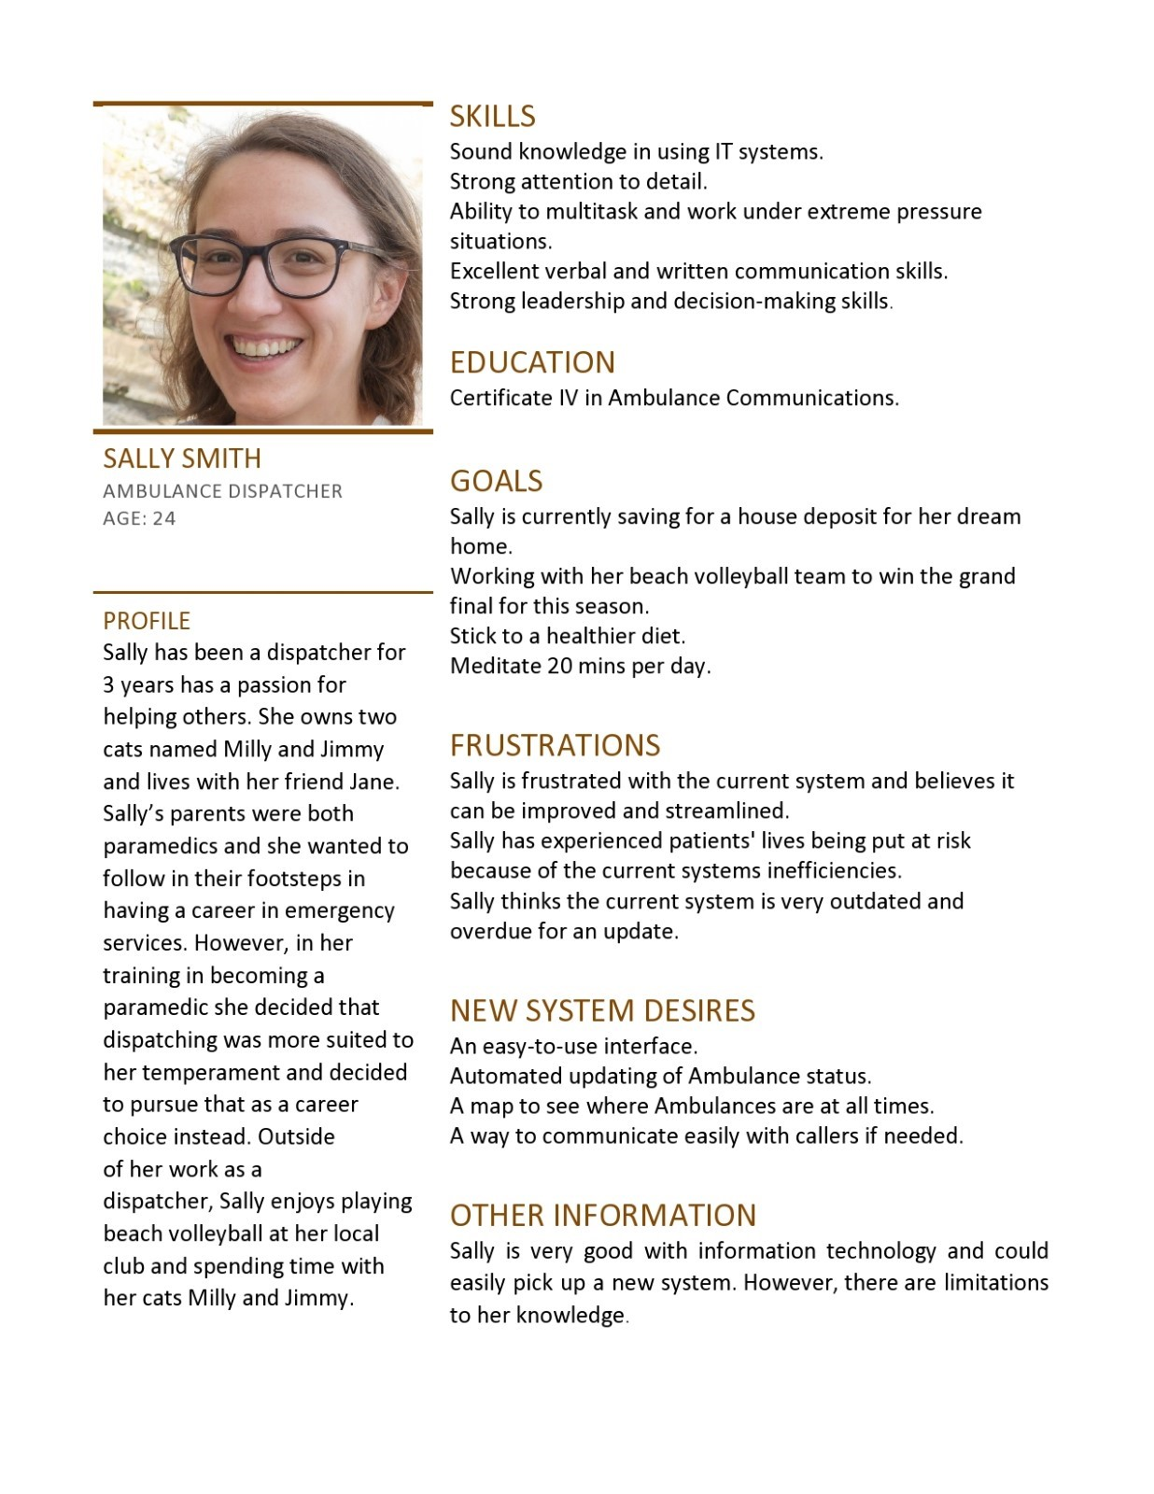

### Dispatcher 2

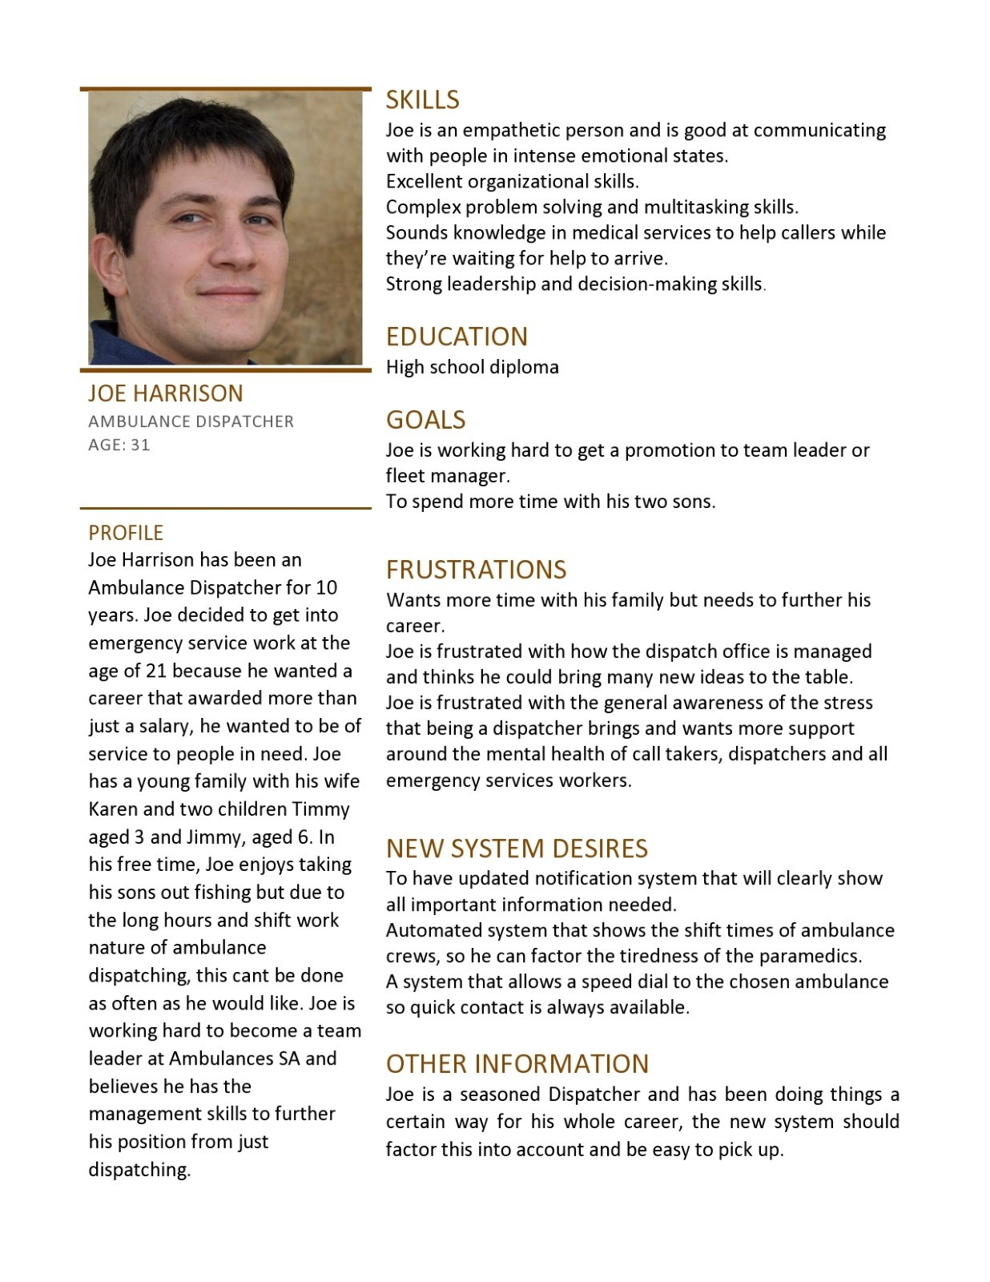

### Paramedic

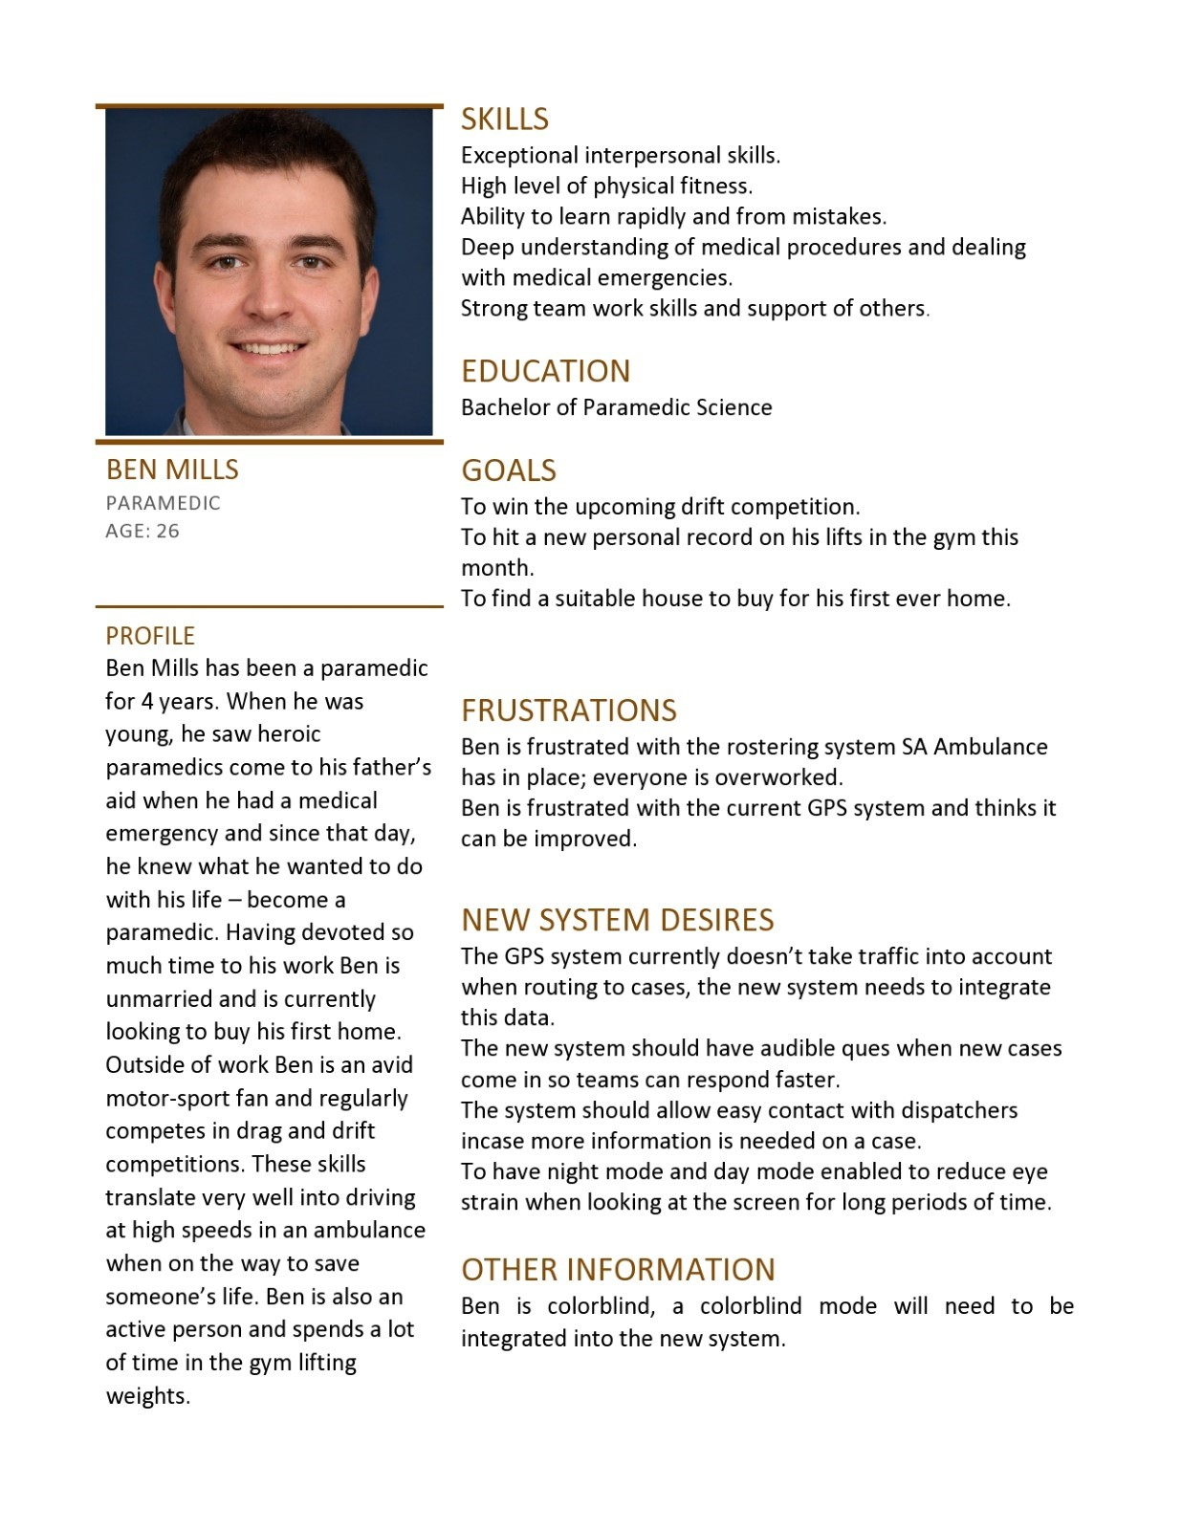

## Task 6 – Matrix of User Stories to Persona’s

|  |  |  |  |
| --- | --- | --- | --- |
| **User Stories** | **Dispatcher 1**  **(Sally Smith)** | **Dispatcher 2**  **(Joe Harrison)** | **Ambulance Driver/Paramedics**  **(Ben Mills)** |
| **RESPONDING PROCESS** | | | |
| US1: As an [ambulance driver], I want to [login the system with saved password] so that [I don’t have to login the system manually.] |  |  |  |
| US2: As an [ambulance driver], I want to [be able to access the information of the upcoming case] so that [I will know which case I am going to deal with.] |  |  |  |
| US3: As an [ambulance driver], I want to [have our Ambulance location to be tracked by GPS through the system] so that [Dispatcher can keep track on our activity on their map.] |  |  |  |
| US4: As an [ambulance driver], I want to [be aware of the other Paramedic] so that [I know who I am going to work with.] |  |  |  |
| US5: As an [ambulance driver], I want to [have a colour-blind mode] so that [I can filter the colours I have trouble seeing out, so the system is easy to use.] |  |  |  |
| US6: As an [ambulance driver], I want to [be notified of various issues at the hospital, if happens, by the Dispatchers] so that [I can be active and flexible in finding the best alternative route to the next recommended hospital.] |  |  |  |
| US7: As an [ambulance driver], I want to [access to my timetable shift] so that [I can be aware of my shift and keep track of my working time.] |  |  |  |
| US8: As an [ambulance driver], I want to [be able see the latest policies and procedures] so that [I can access and follow the news of necessary information.] |  |  |  |
| US9: As an [ambulance driver], I want the system to have [night and day modes] so that [I can reduce eye strain when looking at the screen for long periods of time.] |  |  |  |
| US10: As an [ambulance driver], I want to [have audible ques when an incoming case arrives] so that [we don’t have to be always watching the screen for a new case.] |  |  |  |
| US11: As an [ambulance driver], I want [receive notification about the chosen hospital with some detail information from the Dispatcher] so that [I can get the patient to the suggested hospital as fast as possible.] |  |  |  |
| US12: As an [ambulance driver], I want the [system to have access to google maps traffic data] so that [we can potentially avoid highly dense traffic so we can save time when on route to a patient or hospital.] |  |  |  |
| US13: As an [ambulance driver], I want to [be able to easily update my status] so that [dispatch is always aware of our availability.] |  |  |  |
| US14: As an [ambulance driver], I want the [system to automatically send estimated times of arrival to patients] so that [they know when to expect us.] |  |  |  |
| US15: As an [ambulance driver], I want to [have case notes clearly on display] so that [any special or unusual circumstances are known about before we arrive to the case.] |  |  |  |
| **DISPATCHING PROCESS** | | | |
| US16: As an [Dispatcher], I want to [login the system with saved password] so that [I don’t have to login the system manually.] |  |  |  |
| US17: As a [Dispatcher], I want to [receive clear notifications and categorized cases from Call Taker] so that [I can reduce the amount of time taken to assign them.] |  |  |  |
| US18: As a [Dispatcher], I want to [be able to contact all the Ambulance Crew] so that [I can ask for their availability in case no one is available.] |  |  |  |
| US19: As a [Dispatcher], I want to [have a clear and simple user interface] so that [I can work and manage the case information effectively during stress time.] |  |  |  |
| US20: As a [Dispatcher], I want to [I want to have a map showing all locations of available ambulances in the area] so that [that I can easily dispatch the closest ambulance team to the patient in need.] |  |  |  |
| US21: As an [Dispatcher], I want to [ be notified if multiple people ringing for the same accidents] so that [I can come up with the best dispatch solution.] |  |  |  |
| US22: As a [Dispatcher], I want the [system to automatically update ambulance status from busy to available] so that [I can save time during the dispatch process.] |  |  |  |
| US23: As a [Dispatcher], I want to [receive notification if there are any holes in coverage] so that [arrange and adjust the number of ambulances needed for all areas.] |  |  |  |
| US24: As a [Dispatcher], I want to [have a suitable mechanism to simply but effectively communicate with caller] so that [I can get enough information about the case before or after they hang up.] |  |  |  |
| US25: As an [Dispatcher], I want to [ be informed if there is a high priority call that is close] so that [I can make the best final dispatch decision.] |  |  |  |
| US26: As a [Dispatcher], I want to [notify to the Call Taker that I received the case] so that [they would keep track of the case.] |  |  |  |
| US27: As a [Dispatcher], I want to [be able to notify and send cases information to Paramedic] so that [they can keep track of the process and manage to solve the cases on time.] |  |  |  |
| US28: As an [Dispatcher], I want to [be able to acknowledge the hospital facility] so that [I can notify Paramedics of the issues in that hospital.] |  |  |  |

Task 7 – Storyboards   
Sketch up all the user stories for the application. These are contextual storyboards so are   
representative of the situation the user is interacting the system.

### RESPONSE SYSTEM

**SB1-**. Receive case and hospital ’s location, suggested route though audible ques and visual display.

**Related User Stories:**US2, US3, US10, US11, US27.

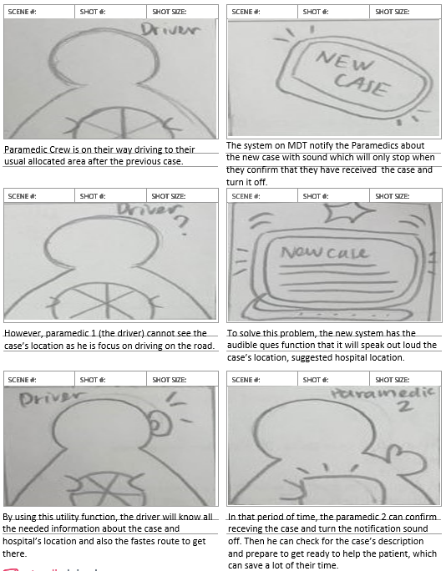

### 

### DISPATCHING SYSTEM

**SB2-.**Solution for multiple people ringing for the same accidents problem.

**Related User Stories:**US21.

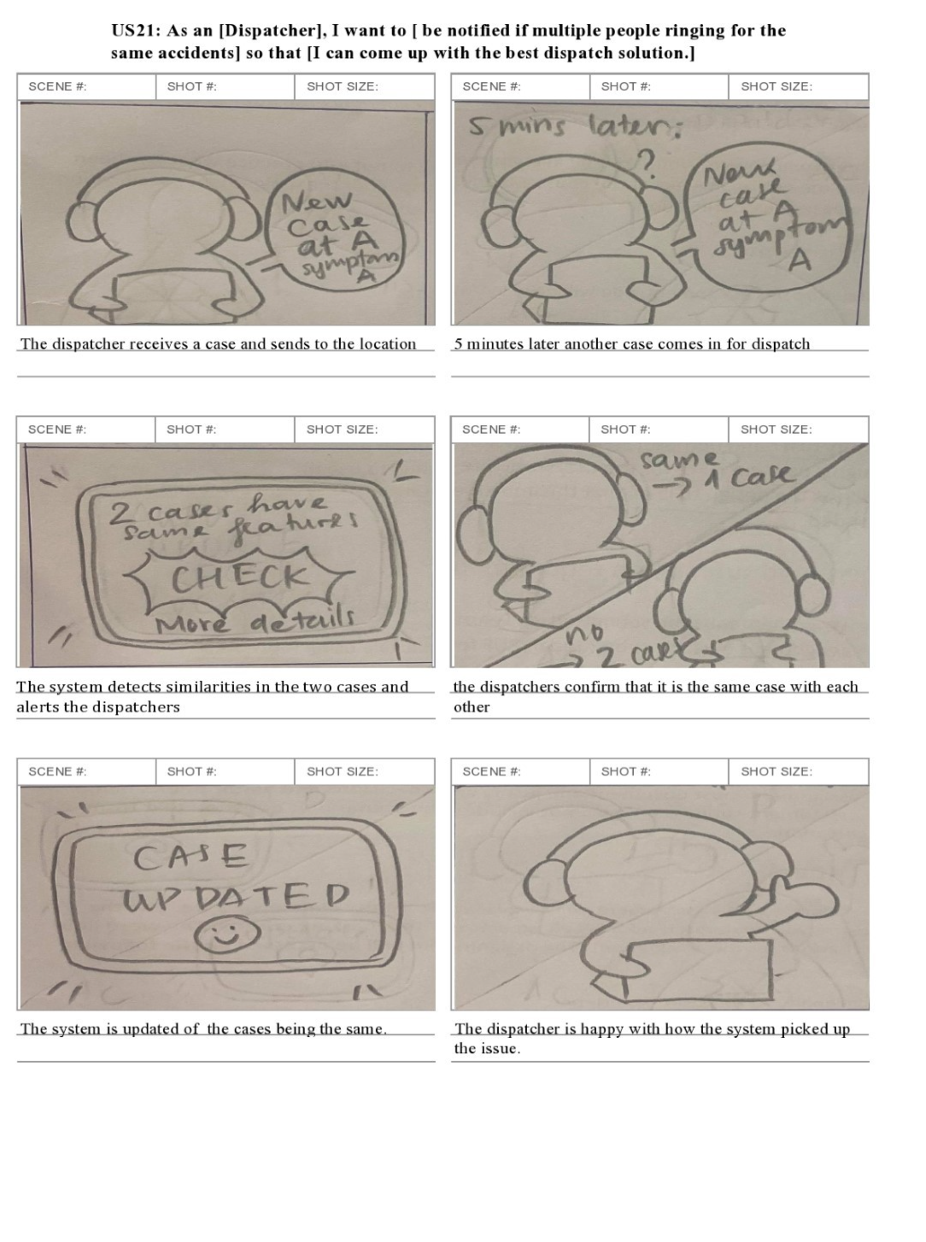

**SB3-.**Solution for high priority call which is close to an ambulance being on the way to a priority 3 call.

**Related User Stories:**US26.

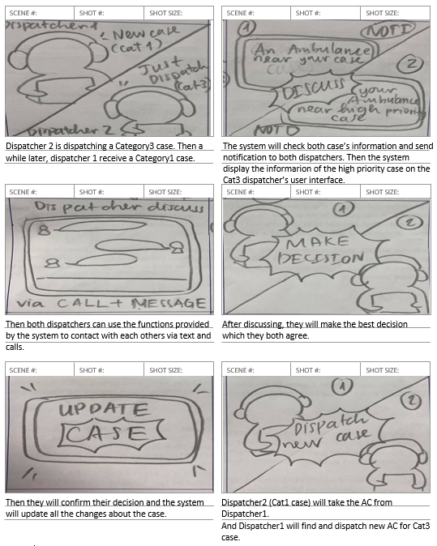

**SB4-**. Solution to solve problems in there is any holes in coverage.

**Related User Stories:**US23.

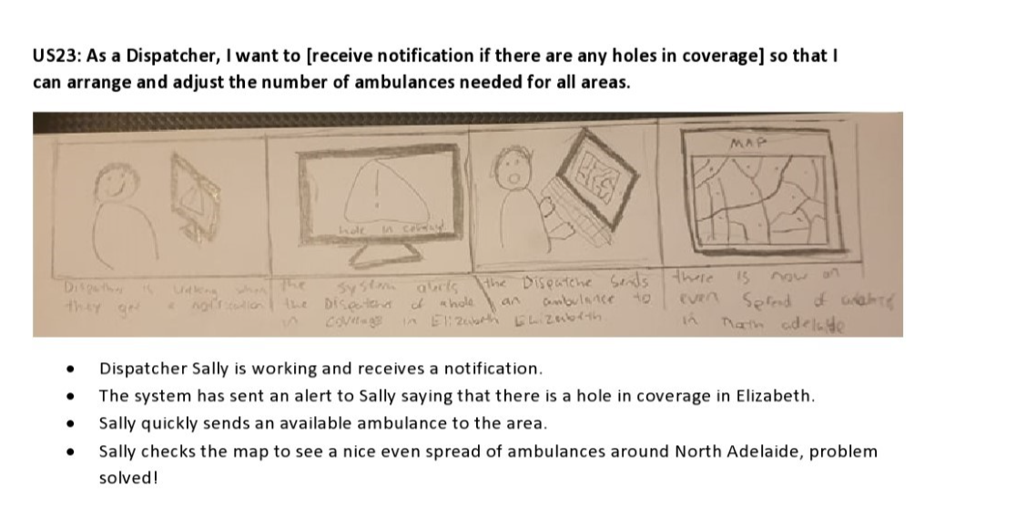

### BOTH SYSTEMS (DISPATCH & RESPONSE)

**SB5-.**Automatically update AC’s location and status for Dispatcher to keep track of.

**Related User Stories:**US13, US23.

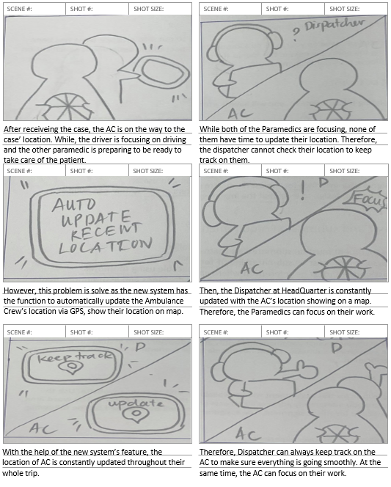

**SB6-.**Interaction between Dispatcher and AC to solve a typical case.

**Related User Stories:**US2, US17, US19.

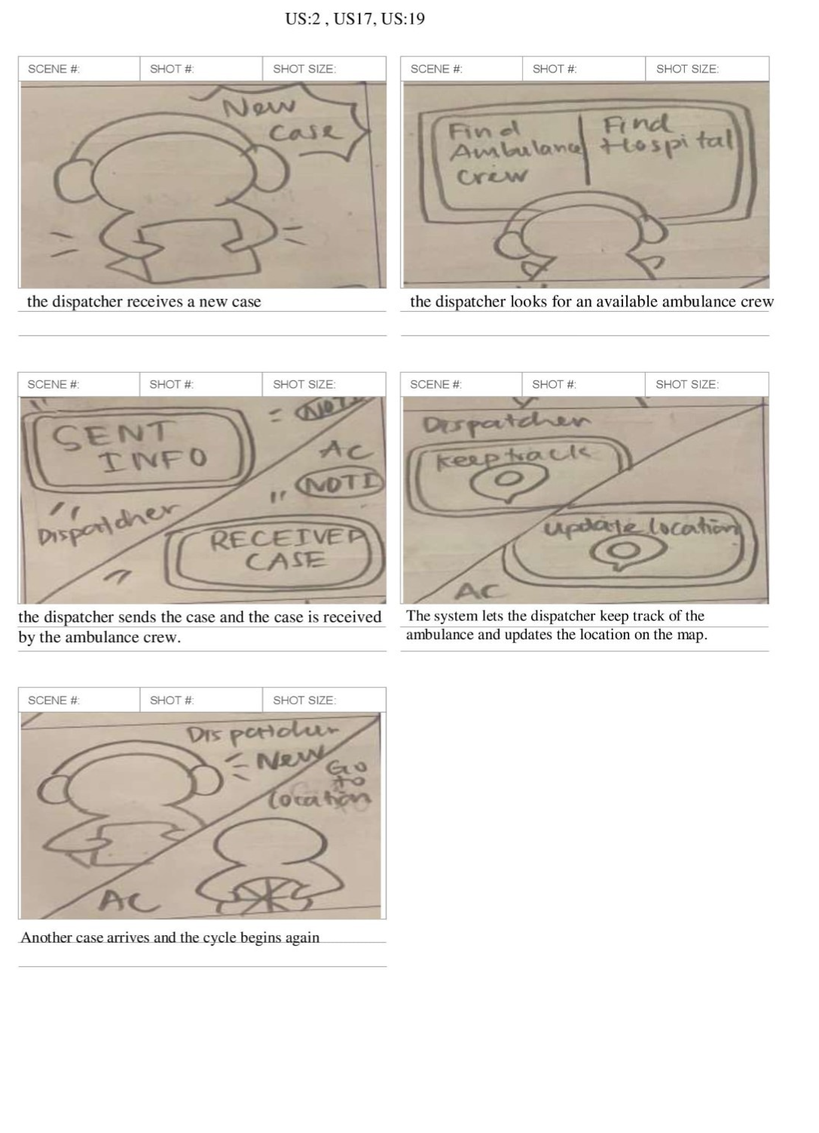

## Task 8 – Information Architecture/Look and Feel

### Typography

We have chosen to use Arial for all the fonts used in the system because it is a familiar and simple font that everyone has seen.

Example:

**SA AMBULANCE**

**CASE 1: CATEGORY 1**

**HOSPITAL**

Royal Adelaide Hospital

**CALLER**

Ellen Ripley

### Colour palette

User interface colours:

|  |  |  |  |
| --- | --- | --- | --- |
|  |  |  |  |

### Case Category color options:

One of our paramedic personas is color blind. So, we have made different color options available for the category of cases so they can easily be seen by people with all types of eyesight. This will be implemented in the account setup process for the system. The rest of the user interface has been kept mostly white to ensure that no other issues can arise with seeing different sections or buttons clearly.

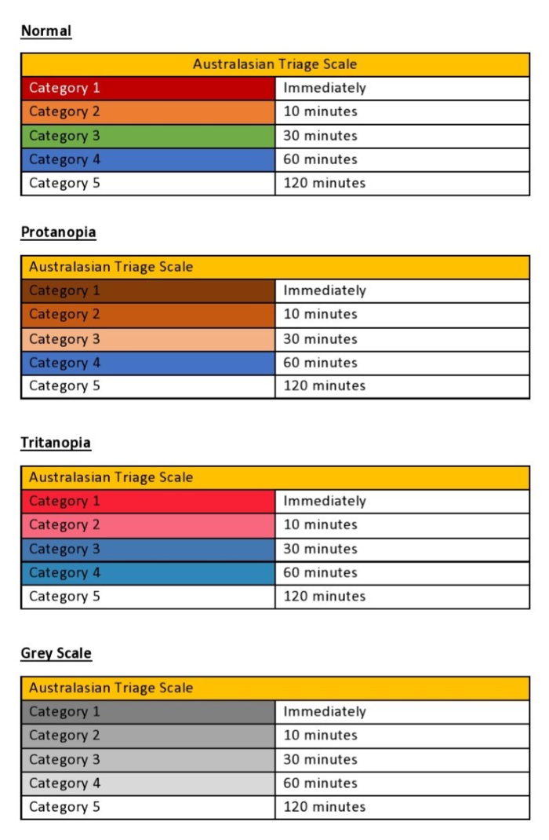   
Iconography

These are all the icons that will be implemented into the system. To add to the simplistic nature of the system we have chosen icons that are commonly seen in almost all software applications or websites. This will make the system easy to pick up and be used with almost no training or have hard learning curves to understand what each page or icon will do.

|  |  |
| --- | --- |
| **Icon** | **Use** |
|  | Drop down list.  Users will use this icon to toggle a drop-down list of options. Such as save password. |
|  | Account.  This icon is for the users account page, this icon was chosen because images of a person a usually used for account buttons. |
|  | Home.  This is the home icon; everyone will be able to recognize this symbol as the home button that will return the user to the home page. |
|  | Notification.  This is a standard notification icon that can be recognized from social media platforms and other applications that need to send notifications to the user. |
|  | Lack of ambulances in specific area  This is an alert symbol that will notify the user of an area on the map that does not have enough ambulances in the area. This will be cleared when an ambulance is sent to fill the void. |
|  | Ambulances are clustered in one area.  This is an alert symbol that will notify the user of an area on the map where ambulances are needlessly clustered. This will be cleared when they are notified and fil other areas. |
|  | Audible ques on and off button.  A simple icon that can be used to toggle the sound on and off if the user wishes. |
|  | Sign in.  Sign in button is used to bring users to the login page. |
|  | Case category  This icon is displayed next to the current case being viewed. |
|  | Back.  A basic back button that returns users to the previous page they were on. |

## Task 9 – Priority List of User Stories (AKA Backlog)

For the prioritization method we decided to go with MoSCoW prioritization, we chose this method because it is a simple but effective way of thinking about what is essential and what can be implemented in later updates.

|  |  |  |  |  |
| --- | --- | --- | --- | --- |
| **MoSCoW Prioritization for Paramedic/Ambulance Driver User Stories** | | | | |
| **Ambulance Driver/Paramedic User Story** | Must have. | Should have. | Could have | Will not have. |
| US1. |  |  |  |  |
| US2. |  |  |  |  |
| US3. |  |  |  |  |
| US4. |  |  |  |  |
| US5. |  |  |  |  |
| US6. |  |  |  |  |
| US7. |  |  |  |  |
| US8. |  |  |  |  |
| US9. |  |  |  |  |
| US10. |  |  |  |  |
| US11. |  |  |  |  |
| US12. |  |  |  |  |
| US13. |  |  |  |  |
| US14. |  |  |  |  |
| US15. |  |  |  |  |

### Paramedic/Ambulance Driver User Stories Ordered by Importance.

**Must haves ordered:**

1. US2. As an [ambulance driver], I want to [be able to access the information of the upcoming case so that [I will know which case I am going to deal with.]
2. US3. As an [ambulance driver], I want to [access the GPS through the system] so that [I can locate the destination and find out the fastest way to get that location.]
3. US12. As an [ambulance driver], I want the [system to have access to google maps traffic data] so that [we can potentially avoid highly dense traffic so we can save time when on route to a patient or hospital]
4. US15. As an [ambulance driver], I want to [have case notes clearly on display] so that [any special or unusual circumstances are known about before we arrive to the case.]
5. US10. As an [ambulance driver], I want to [have audible ques when an incoming case arrives] so that [we do not have to be always watching the screen for a new case.]
6. US11. As an [ambulance driver], I want [to be informed about the chosen hospital from the Dispatcher] so that [I can get the patient to the best hospital as fast as possible.]

**Should haves ordered:**

1. US13. As an [ambulance driver], I want to [be able to easily update my status] so that [dispatch is always aware of our availability.]
2. US8. As an [ambulance driver], I want to [be able see the latest policies and procedures] so that [I can access and follow the news of necessary information.]
3. US6. As an [ambulance driver], I want to [be able to acknowledge the Hospital facility] so that [I can be informed with the issues in that Hospital.]
4. US4. As an [ambulance driver], I want to [be aware of the other Paramedic] so that [I know who I am going to work with.]
5. US1. As an [ambulance driver], I want to [login the system with saved password] so that [I do not have to login the system manually.]
6. US5. As an [ambulance driver], I want to [have a colorblind mode] so that [I can filter the colors I have trouble seeing out, so the system is easy to use.]

**Could haves ordered:**

1. US14. As an [ambulance driver], I want the [system to automatically send estimated times of arrival to patients] so that [they know when to expect us.]
2. US7. As an [ambulance driver], I want to [access to my timetable shift] so that [I can be aware of my shift and keep track of my working time.]
3. US9. As an [ambulance driver], I want the system to have [night and day modes] so that [I can reduce eye strain when looking at the screen for lengthy periods of time.]

|  |  |  |  |  |
| --- | --- | --- | --- | --- |
| **MoSCoW Prioritization for Dispatcher User Stories** | | | | |
| **Ambulance Dispatcher User Story** | Must have. | Should have. | Could have | Will not have. |
| US16. |  |  |  |  |
| US17. |  |  |  |  |
| US18. |  |  |  |  |
| US19. |  |  |  |  |
| US20 |  |  |  |  |
| US21. |  |  |  |  |
| US22. |  |  |  |  |
| US23. |  |  |  |  |
| US24. |  |  |  |  |
| US25. |  |  |  |  |
| US26. |  |  |  |  |
| US27. |  |  |  |  |
| US28. |  |  |  |  |

### Dispatcher User Stories Ordered by Importance.

**Must haves ordered:**

1. US17. As a [Dispatcher], I want to [receive clear notifications and categorized cases from Call Taker] so that [I can reduce the amount of time taken to assign them.]
2. US27. As a [Dispatcher], I want to [be able to notify and send cases information to Paramedic] so that [they can keep track of the process and manage to solve the cases on time.]
3. US20. As a [Dispatcher], I want to [I want to have a map showing all locations of available ambulances in the area] so that [that I can easily dispatch the closest ambulance team to the patient in need.]
4. US18. As a [Dispatcher], I want to [be able to contact all the Ambulance Crew] so that [I can ask for their availability in case no one is available.]
5. US23. As a [Dispatcher], I want to [receive notification if there are any holes in coverage] so that I can[arrange and adjust the number of ambulances needed for all areas.]

**Should haves ordered:**

1. US25. As an [Dispatcher], I want to [ be informed if there is a high priority call that is close] so that [I can make the best final dispatch decision.]
2. US21. As an [Dispatcher], I want to [ be notified if multiple people ringing for the same accidents] so that [I can produce the best dispatch solution.]
3. US22. As a [Dispatcher], I want the [system to automatically update ambulance status from busy to available] so that [I can save time during the dispatch process.]
4. US24.: As a [Dispatcher], I want to [have a suitable mechanism to simply but effectively communicate with caller] so that [I can get enough information about the case before or after they hang up.]
5. US26. As a [Dispatcher], I want to [notify to the Call Taker that I received the case] so that [they would keep track of the case.]
6. US19. As a [Dispatcher], I want to [have a clear and simple user interface] so that [I can work and manage the case information effectively during stress time.]

**Could haves ordered:**

1. US16. As an [Dispatcher], I want to [login the system with saved password] so that [I do not have to login the system manually.]
2. US28. As an [Dispatcher], I want to [be able to acknowledge the hospital facility] so that [I can notify Paramedics of the issues in that hospital.]

## Task 10 – Prototype

### Ambulance Driver (Response Process)

This is an interactive digital prototype of MDT for Ambulance Driver which allows Paramedics to access the case information as well as using GPS via system to find the best route and update their recent status during Response process. They are also able to receive notification from Dispatcher about the upcoming case and directly contact via phone call for detail clarification.

<https://antruong964446.invisionapp.com/prototype/ckq1ar4eg007sc801h086v81x/play>

Here is an overview of the prototype:

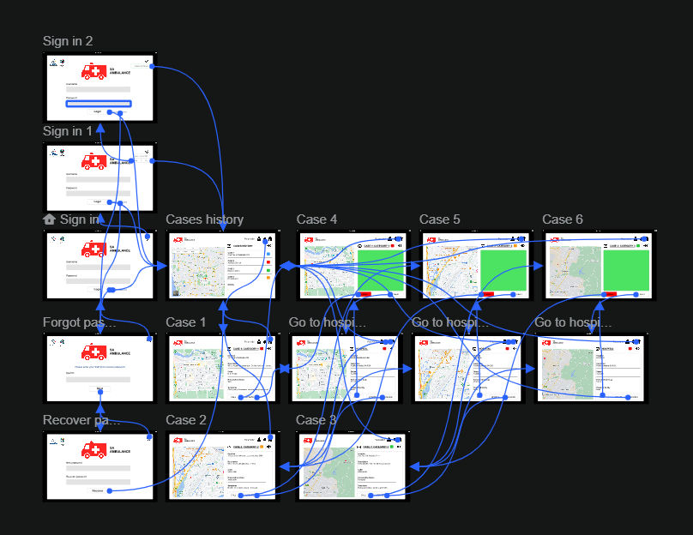 

Sign in interface that allows Paramedic to sugn in the system  
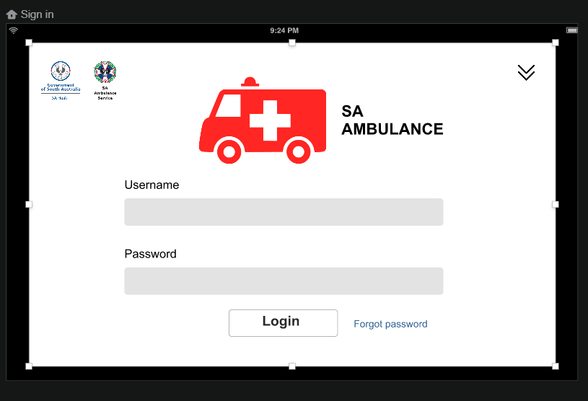

Save password of the paramedic

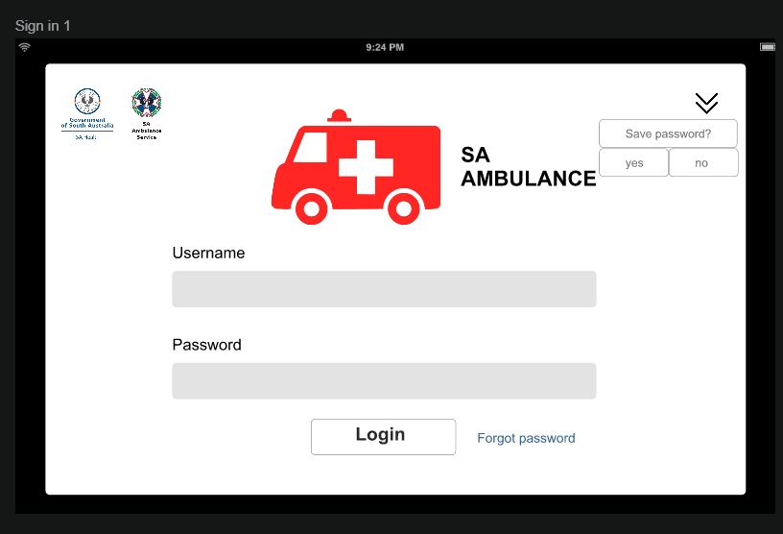

Recover password incase they forgot

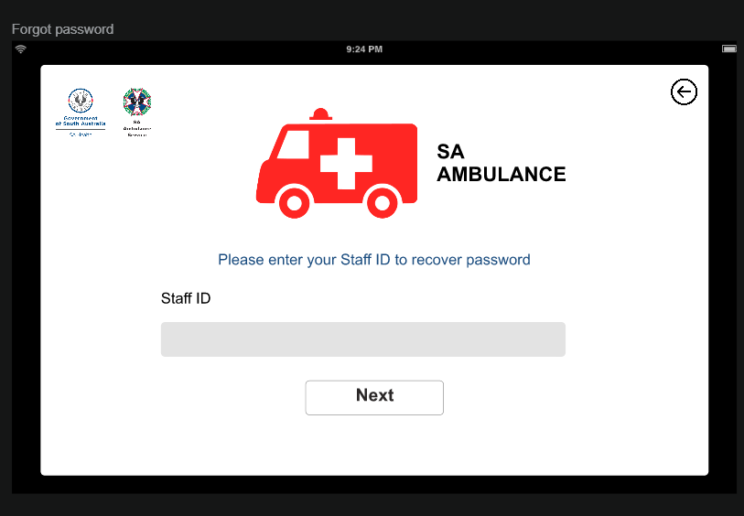

Main menu (display cases history)

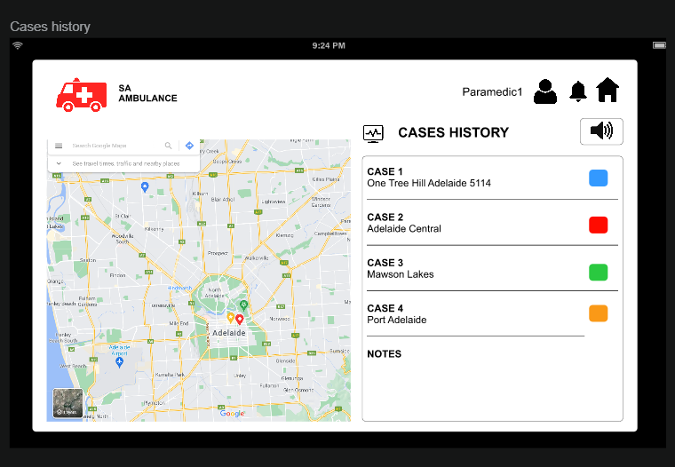

Receive case details.

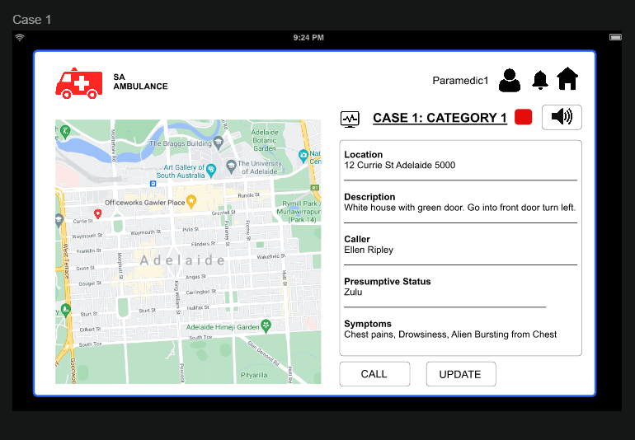

Call for more information.

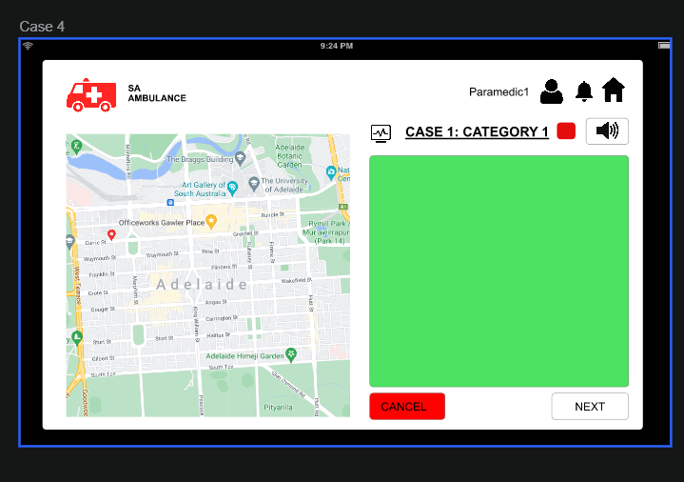

Direct to hospital information

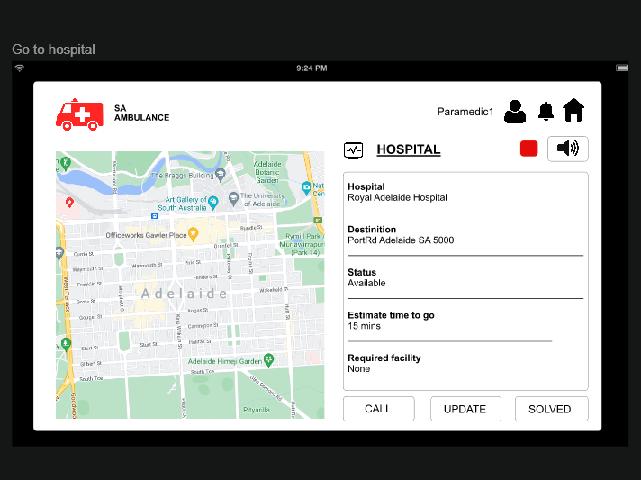

### Dispatcher (Dispatching Process)

Dispatching system enables Dispatchers to dispatch the case through the system with functional features to optimise working quality as well as enhance user interface to simplify the dispatch process, which reduces users’ stress level.

<https://antruong964446.invisionapp.com/prototype/ckq25lw03000dck01jp7cvsyw/play>

Dispatcher sign in interface

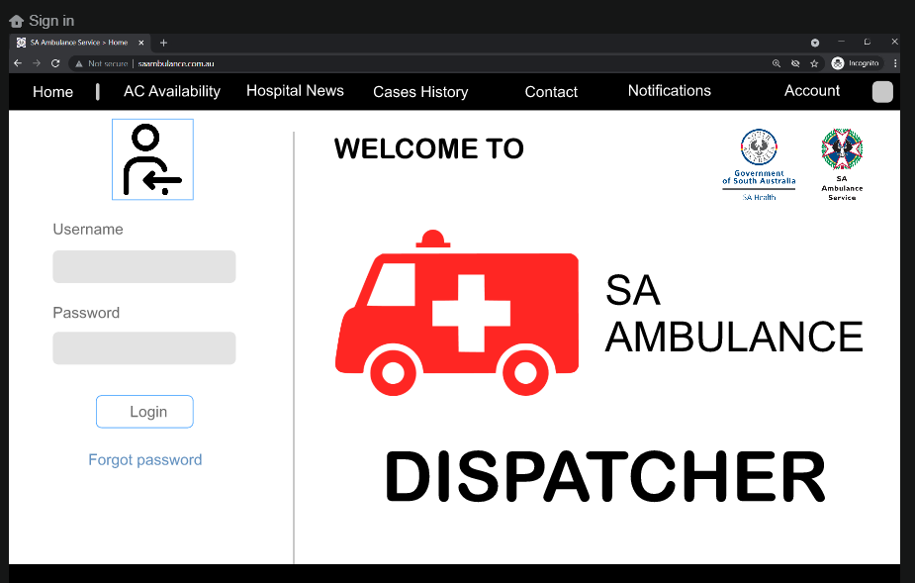

Recover account (in case dispatcher forgot password).

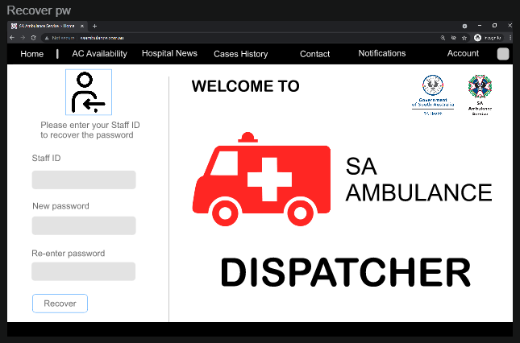

Sign in 1

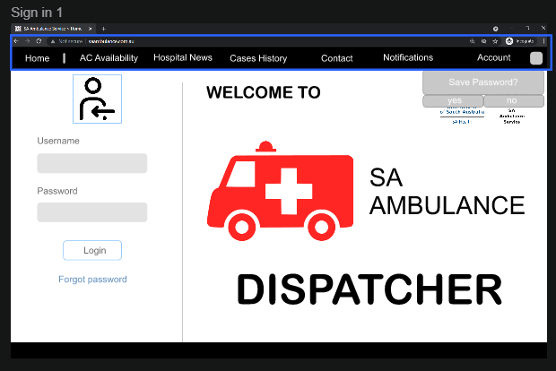

Main menu: Home

(Display ambulance’s location in different areas,

 alert dispatcher if their area is lack of ambulance or the ambulance are clustered,

give suggestions to solve this problem.)

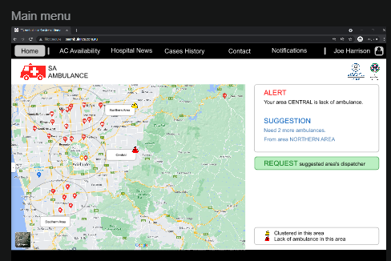

Main Menu: Home

(Display ambulance’s location in different areas,

request conversation with the recommended area’s dispatcher to discuss (can be both text and call if needed).

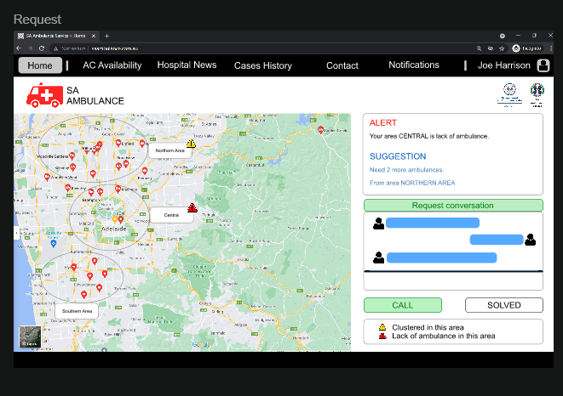

Ambulance Crew Availability

(Show map with ambulance location in area for specific dispatcher, along with the table shows the AC status, and button to request more ambulance if need, they can call dispatcher in other area to request to ask for help).

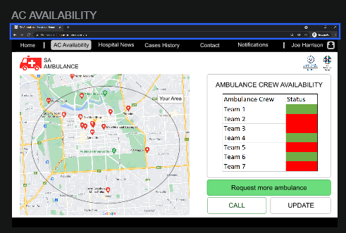

Hospital News

(Show recommendations for closest available hospital in their area, with the table that list the hospital, their address and their issues, in case there is any).

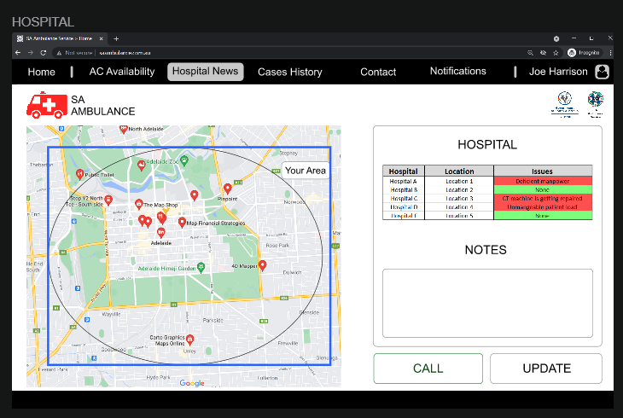

Case History (Display case history with their location and category).

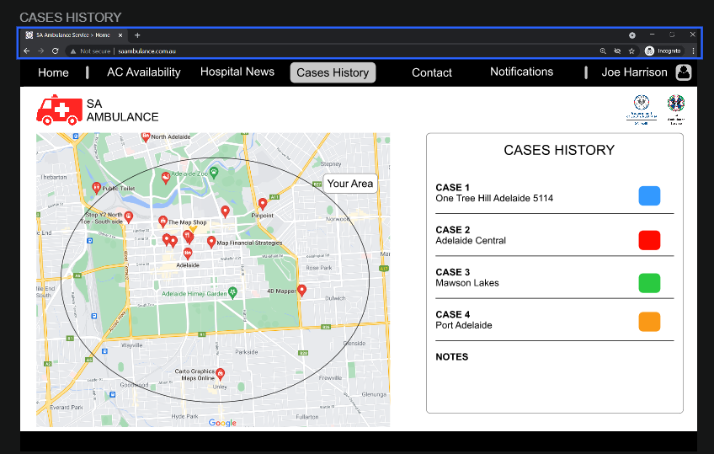

Contact

(Display the location of the case and ambulance, call button to contact caller, ambulance crew and also other dispatcher, and button to update information).

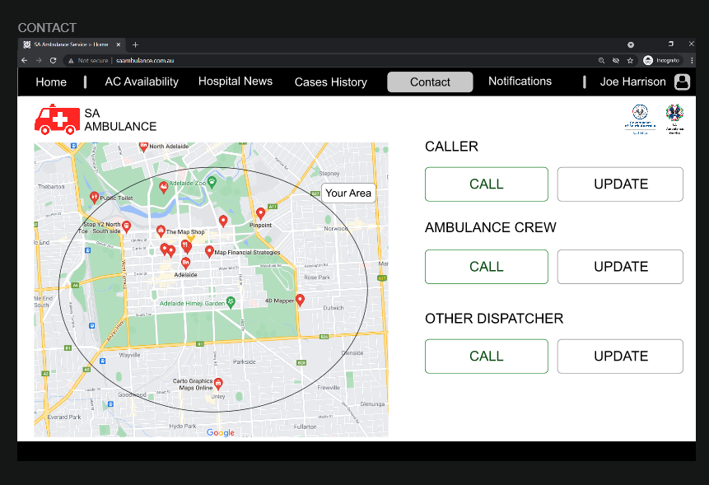

Notifications

(Dispatcher receives case’s notification with sounds to acknowledge them about the case;

the sound will continue ringing until dispatcher confirm the case and turn the sound of by pressing the sound icon,

then the case’s information will be displayed at the same time when Call Taker takes information from caller and insert information in the system;

there is also button to call the Caller back if provided information is not enough.)

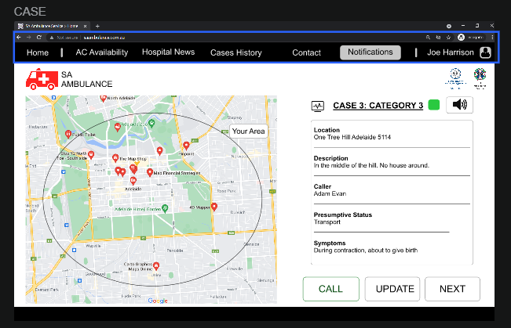

Contact

(Dispatcher interface while making any call).

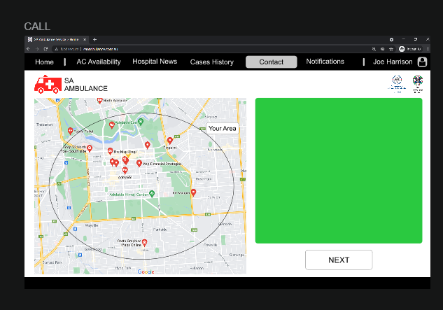

Case Dispatch

(Display Ambulance Crews’ location and the recommended hospitals with location).

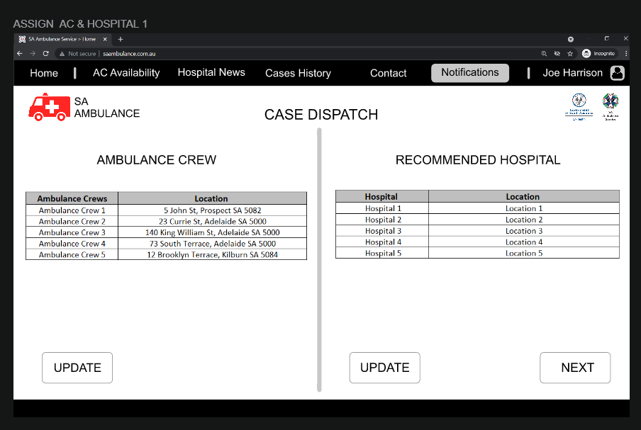

High Priority Case Notification

(Dispatchers receive notification if there is a high priority case that is near the ambulance that they have assigned to the case location; the system displays the information of the high priority case; then they can contact the priority case’s dispatcher to discuss and solve the case by both text and call method.)

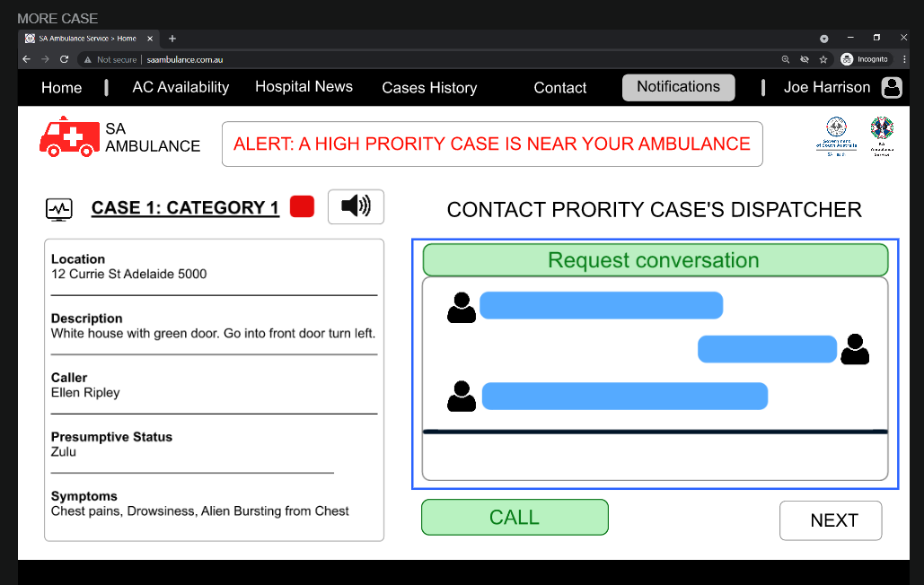

## REFERENCES

1. “How to Use Color Blind Friendly Palettes to Make Your Charts Accessible.” *Venngage*, 9 Apr. 2021, [venngage.com/blog/color-blind-friendly-palette/.](https://venngage.com/blog/color-blind-friendly-palette/)
2. Name=Department for Health and Wellbeing; address=11 Hindmarsh Square, Adelaide. “SA Health.” *Home*, Scheme=AGLSTERMS.AglsAgent; CorporateName=Department for Health and Wellbeing; Address=11 Hindmarsh Square, Adelaide, SA, 5000; Contact=+61 8 8226 6000, [www.sahealth.sa.gov.au/wps/wcm/connect/public+content/sa+health+internet/home/home](http://www.sahealth.sa.gov.au/wps/wcm/connect/public+content/sa+health+internet/home/home).
3. Service, SA Ambulance. “SA Ambulance Service.” *SA Ambulance Service > Home*, [www.saambulance.com.au/](http://www.saambulance.com.au/).
4. “InVision: Digital Product Design, Workflow & Collaboration.” *Invisionapp, Inc.*, [www.invisionapp.com/](http://www.invisionapp.com/).